**Prerequisite**

**Create a database “TicketTracker_db” in mysql**

**Userid : root**

**Password : root**

**Tools :** **It works well with Chrome browser**

**Test #1**

Go to browser address bar type in the following

Localhost:8080

Application opens up as below

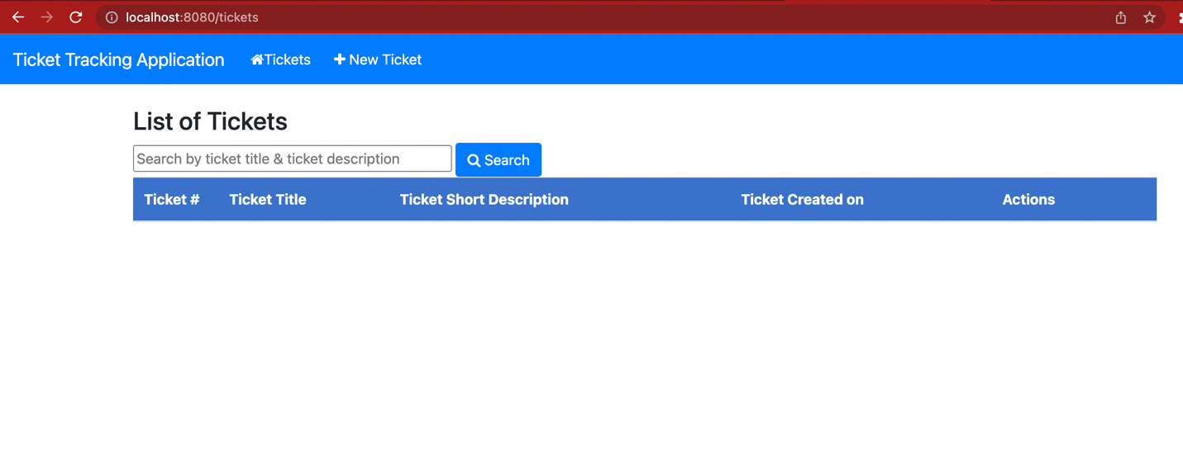

**Test#2:Creating a Ticket**

Click on the New Ticket on the menu bar ()

It opens up the screen “New Ticket” to enter details as below

1. Creating a Ticket

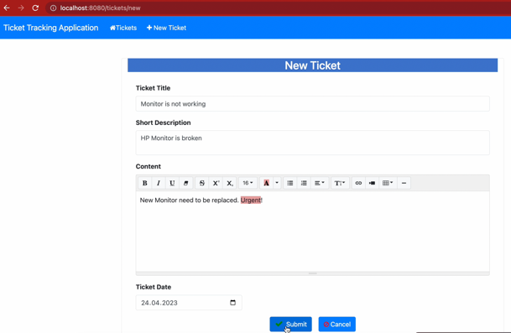

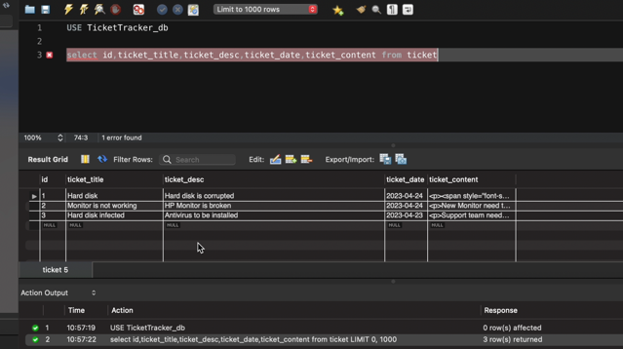

**Test#3. Editing**

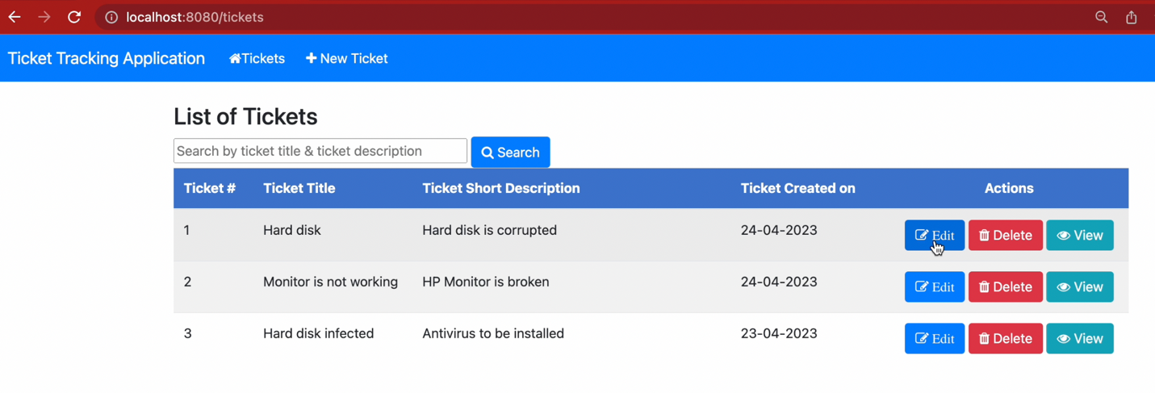

Adding information (1 TB HDD) to the following fieldsTicket Title, Short description and content with (1 TB HDD)

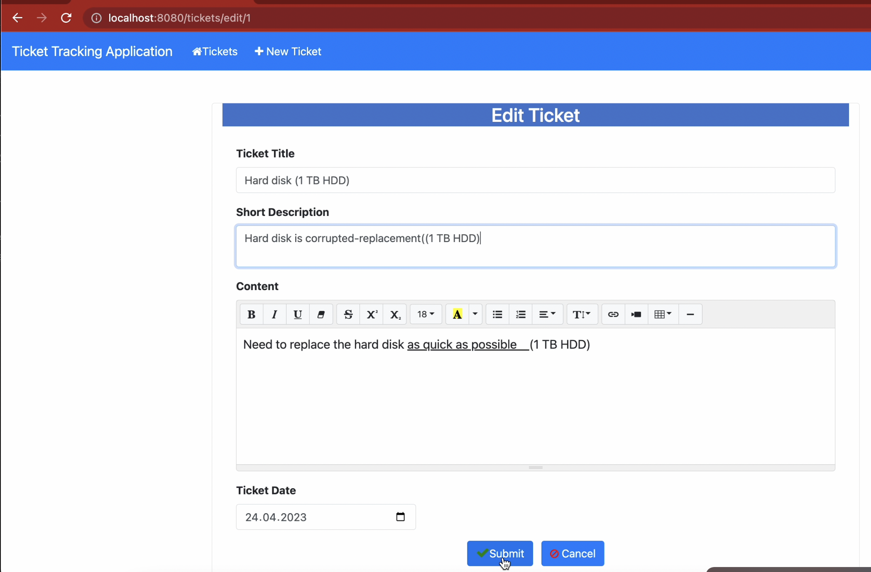

After adding it goes to homepage

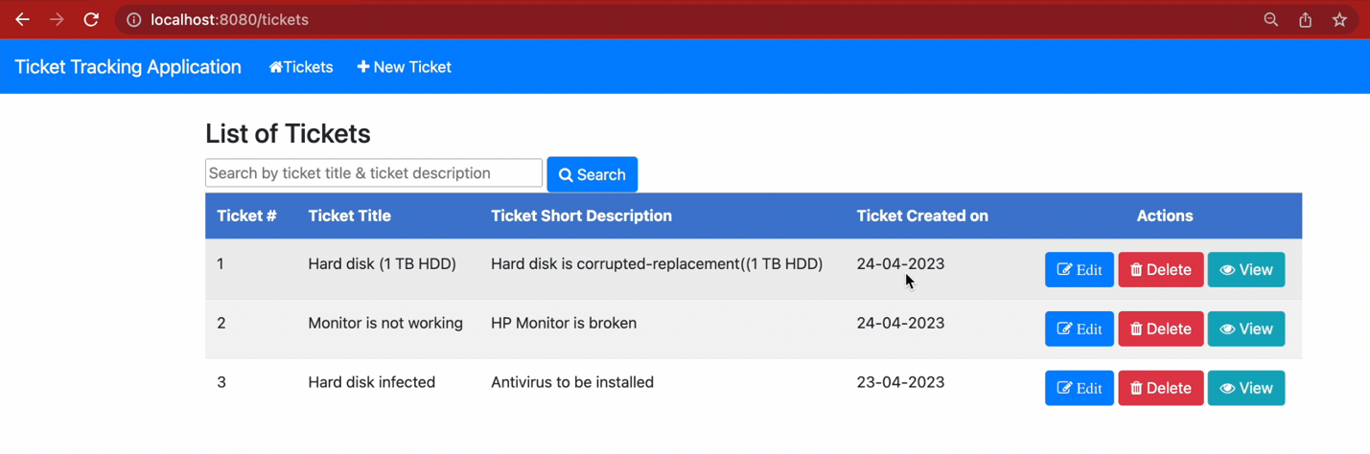

Updated the db as below

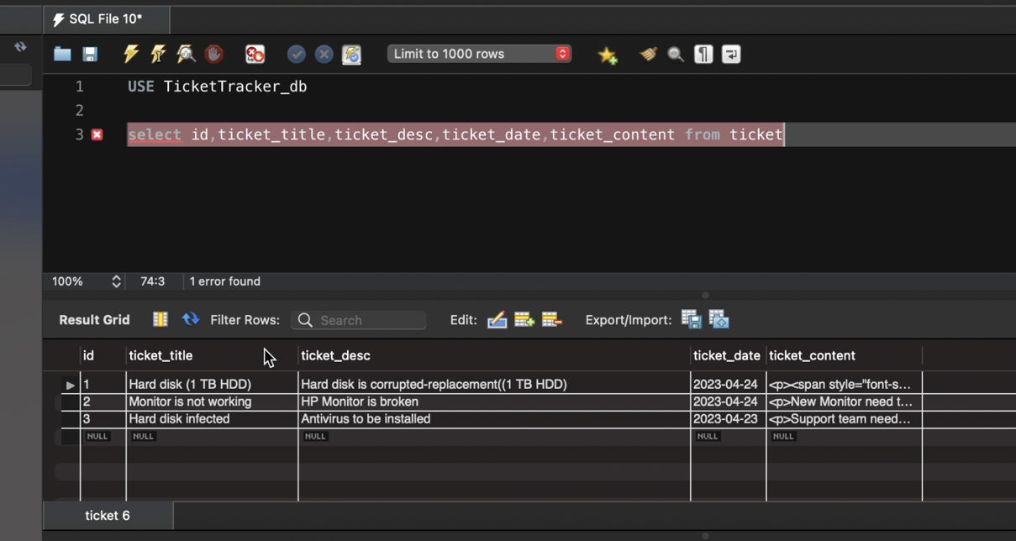

Testing#4:Viewing the ticket

Clicking on the first ticket#1

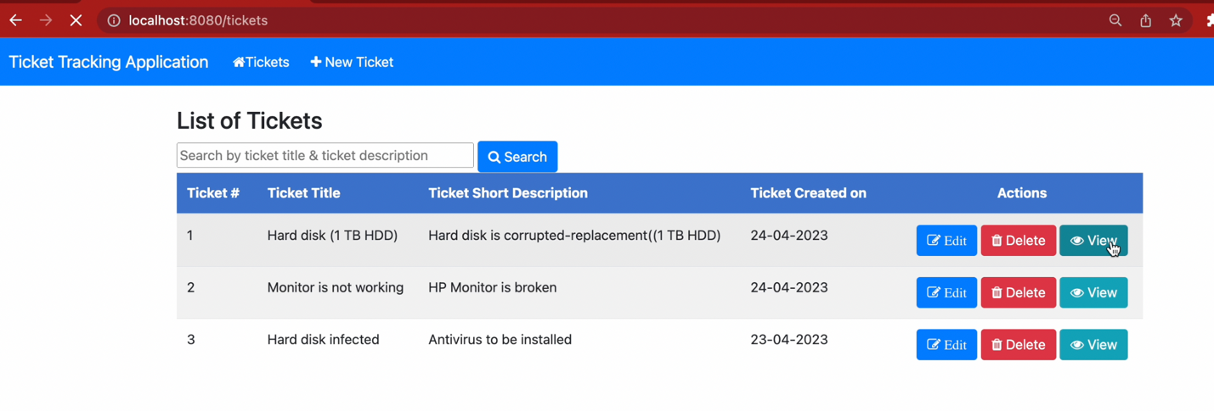

The fields are non-editable and back button to go back main page

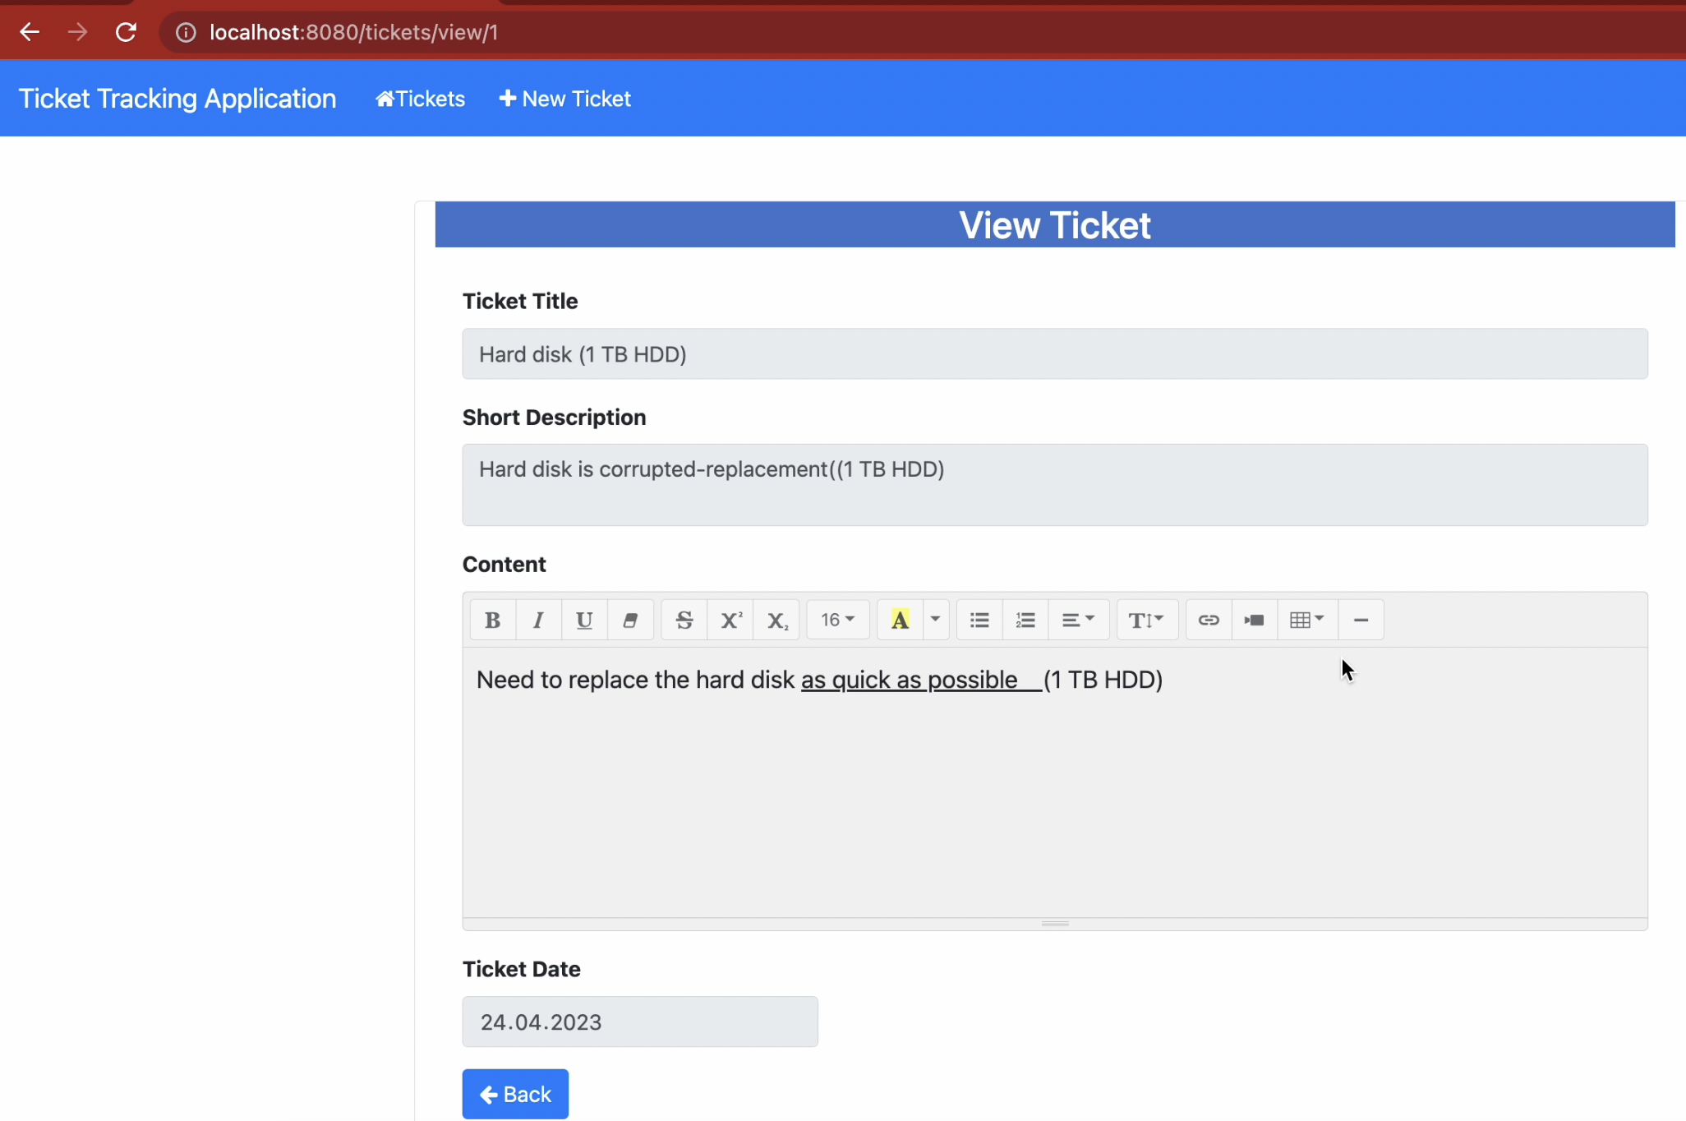

Viewing Ticket#2

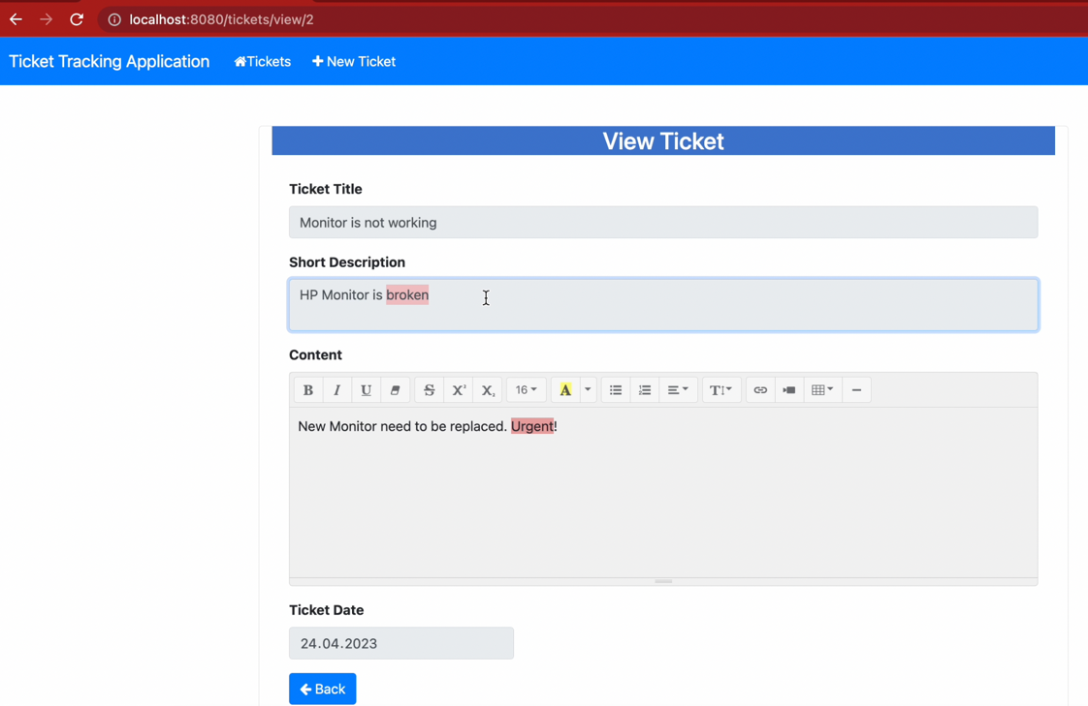

Viewing ticket No#3

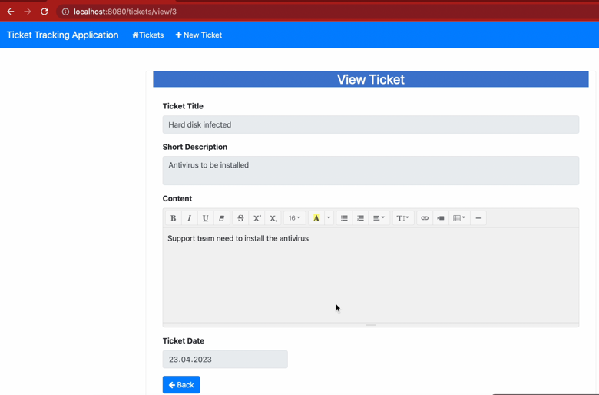

Testing#5 : Deleting ticket no.3

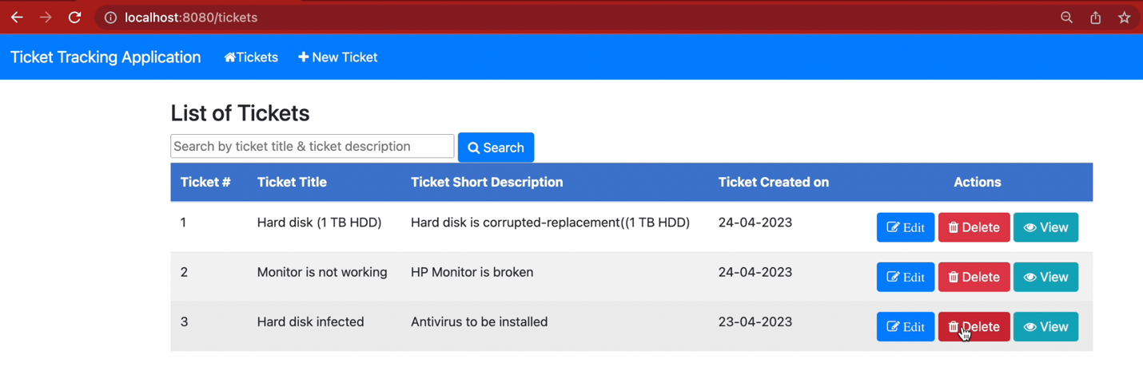

After clicking the delete button, it removes from the database and refreshes the new list

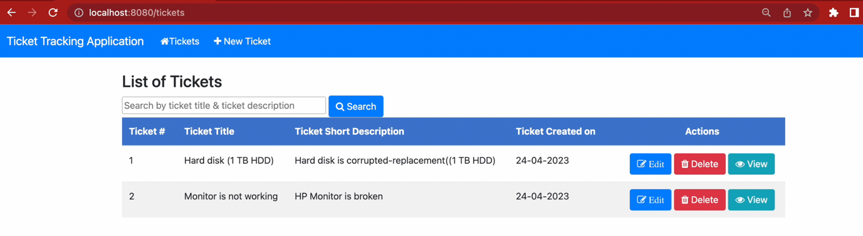

Ticket no#3 not present in the db

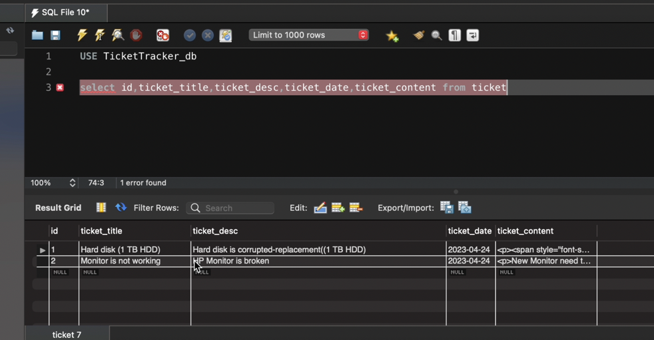

Testing #6: Search Functionality

Following list of tickets created to test the seach functionality

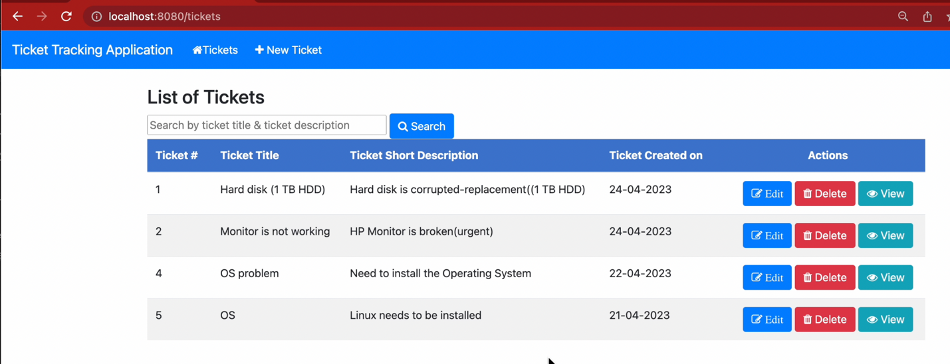

Entering search field: OS

Shows the Result as below

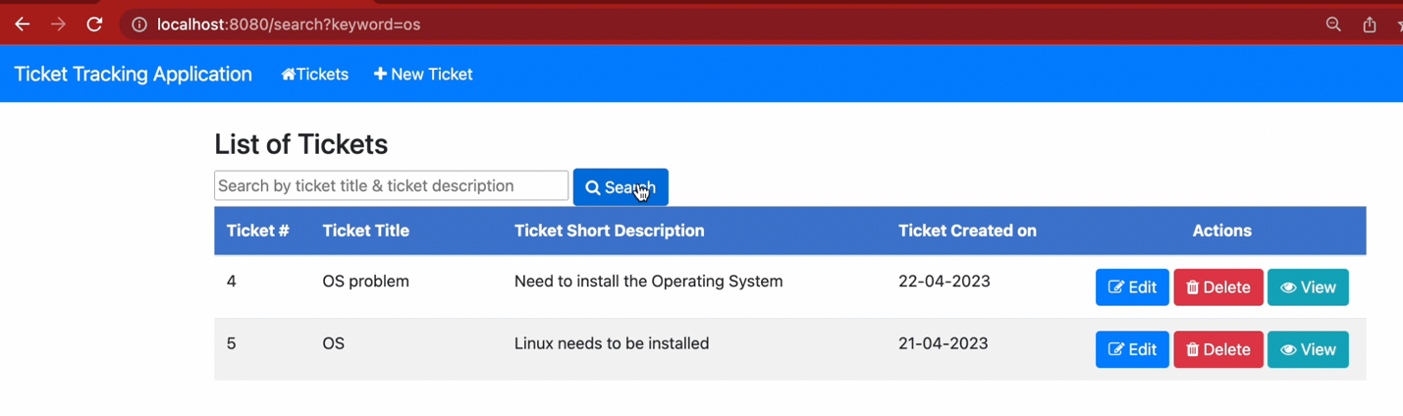

Click on the search button again it brings all the tickets

Enter Monitor in the search field

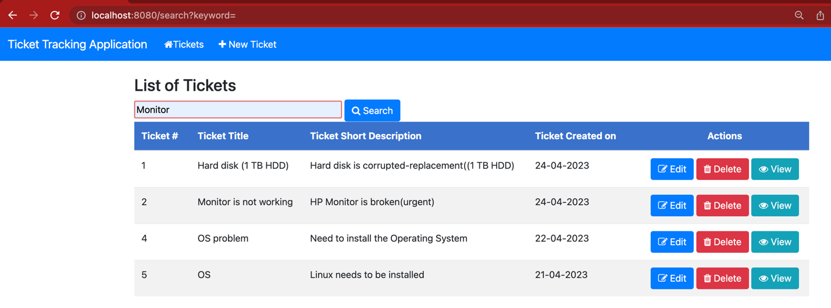

Click on the search button

Shows the result as below

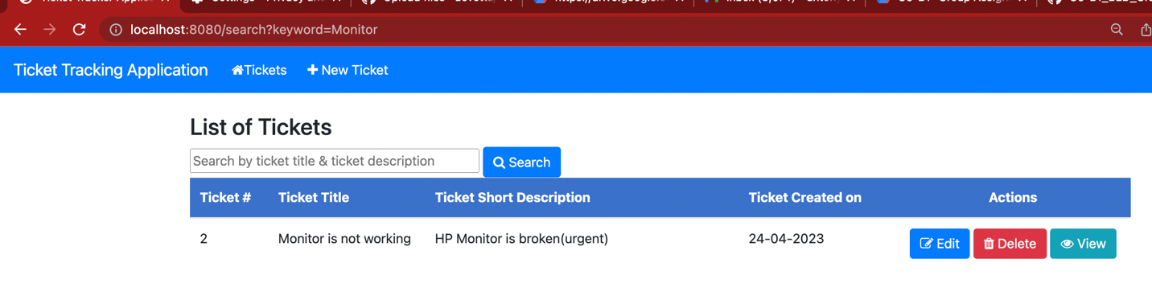

Enter word ‘need’ in the search field

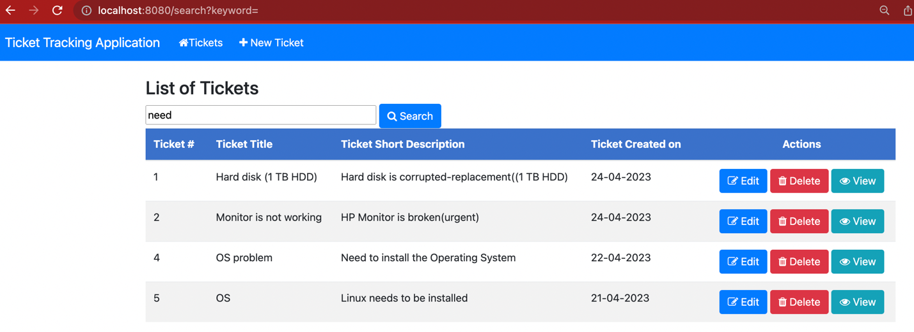

Click on the search button

Shows the result as below

